

Delivery Dash Activity

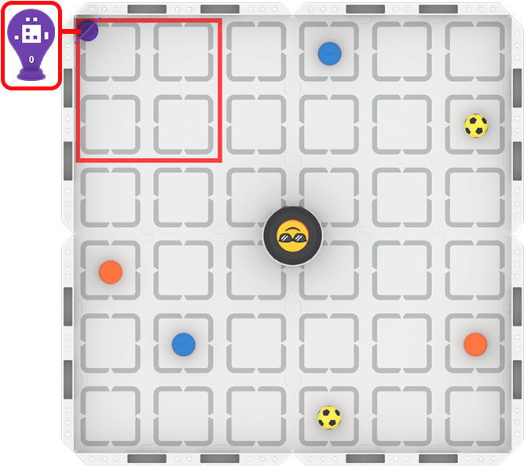 | Drive your robot to find and deliver items to the collection zone in record time!

Challenge: Use the VEX AIM Coding Robot to find all of the sportsballs and barrels and deliver them to the collection zone as quickly as possible.
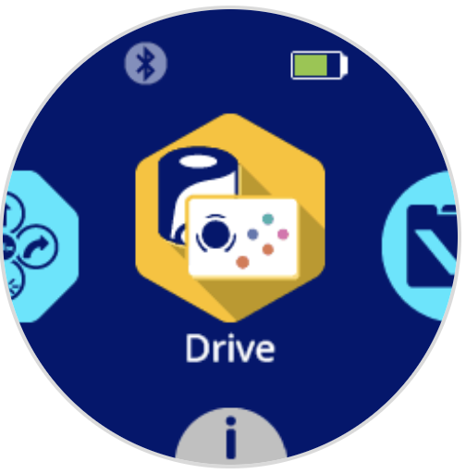

Set Up and Rules:
- Use Drive Mode to complete the challenge with your robot.
- Your robot starts in the center of the field, facing any direction.
- Reset the barrels and sportsballs on the field before each run.
- Try to improve your precision, the efficiency of your path, or your overall time with each run.

Reminders and Pro Tips
- The joystick moves the robot in any direction. The Left and Right buttons ◀▶ will make the robot slide to the left or right in a straight line.
- The Down button ▼ triggers the Kicker to kick a sportsball or place a barrel.
- Pro Tip: The Up button ▲ triggers AI Vision Sensor enabled movement. Pressing the Up button will make the robot turn and move to a barrel or sportsball. The robot will indicate if no object is detected.

Delivery Dash

Activity Notes

Hands-on time for this activity is approximately 30-45 minutes.

Preparing for the Activity

No additional materials are needed for this activity beyond those listed in the Instructor Notes for VEX AIM Activities.

Set up the field as shown.
- Mark a corner collection zone (shown here in red).
- Place an AprilTag in the collection zone at the top left corner of the field.
- Scatter starting locations for 2 blue barrels, 2 orange barrels, and 2 sportsballs around the field. Mark each location to help with resetting the field.
- Mark the starting location of the robot in the center of the field.

Facilitating Delivery Dash

- Introduce the activity. Share the context here to help students connect what they will do with the robot to real-world applications.
 | One of the most exciting things about robotics is that the same challenge can have many different solutions. Two teams might have the same robot and the same goal, but choose totally different strategies to get there.  In this activity, you’ll start by driving your robot and exploring what it can do. This is your chance to investigate how the robot moves, how it turns, how it approaches objects, and what strategies seem to work best. As you drive, you are thinking like an engineer: observing what happens, making decisions, testing ideas, and adjusting your approach.  You do not need to know the answer before you begin. Robotics is about trying ideas, learning from what happens, and improving as you go. Start with curiosity, listen to your teammates, and see what your team can discover together.
- Introduce Drive Mode. Walk students through the steps to begin driving the robot. Use this article for reference.
  - Have students explore the different ways the robot can move using the joysticks and controller buttons.
  - The Up button ▲ triggers AI Vision Sensor enabled movement. Pressing the Up button will make the robot turn and move to a barrel or sports ball. The robot will indicate if no cargo is detected.
  - Call attention to the ways in which the emojis, LEDs, and sounds change as students are driving. What do students notice about how these features are used in Drive Mode?
  - Ask students about what is similar or different about using the Kicker to place a barrel versus a ball. Why is it different? How might the robot be making that decision?

- Direct students to start the Delivery Dash activity.
  - Move around the room and talk with students, asking questions like:
    - How are you deciding the order to pick up the objects?
    - If the collection zone were in a different location, would you change your path? Why or why not?
    - What is one challenge you had to figure out with your partner? How did you solve the problem together?
  - Students should start the robot from the same location each time, but can navigate the Field however they choose.
  - Once an object is placed in the collection zone, students can remove it from the field by hand.

Extending the Activity

- Spend more time investigating Drive Mode. Use the Drive Mode Scavenger Hunt AIM Activity to do a deeper dive into Drive Mode. Have students try to answer all of the questions themselves, then compare answers with another group.

- Complete the activity with Button Coding. Have students code their robot using Button Coding to pick up and deliver barrels and/or sportsballs to the collection zone. Use this article to learn about Button Coding.
  - Take it even further with VEXcode AIM. See the articles in the VEXcode AIM section of the VEX Library for additional information.

